# **Design of Relational Schemas, Creation of Database and Tables for their project**

**Job Portal Database Schema**

**1.DATABASE CREATION:**

CREATE DATABASE job_portal;

USE job_portal;

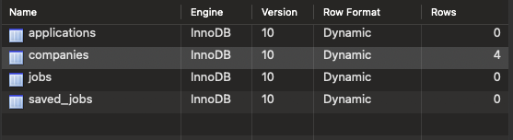

**2.Companies TABLE:**

CREATE TABLE companies (

id SERIAL PRIMARY KEY,

created_at TIMESTAMPTZ DEFAULT CURRENT_TIMESTAMP,

name TEXT NOT NULL,

logo_url TEXT

);

INSERT INTO companies (name, logo_url) VALUES

('Google', 'https://logo.com/google.png'),

('Microsoft', 'https://logo.com/microsoft.png'),

('Amazon', 'https://logo.com/amazon.png');

**3.Jobs Table:**

CREATE TABLE jobs (

id SERIAL PRIMARY KEY,

created_at TIMESTAMPTZ DEFAULT CURRENT_TIMESTAMP,

recruiter_id TEXT NOT NULL,

title TEXT NOT NULL,

company_id INT NOT NULL,

description TEXT,

location TEXT,

requirements TEXT,

isOpen BOOLEAN DEFAULT TRUE,

FOREIGN KEY (company_id) REFERENCES companies(id) ON DELETE CASCADE

);

INSERT INTO jobs (recruiter_id, title, company_id, description, location, requirements, isOpen) VALUES

('recruiter_001', 'Software Engineer', 1, 'Develop and maintain software applications', 'New York', 'Experience with Java, SQL, and APIs', TRUE),

('recruiter_002', 'Data Analyst', 2, 'Analyze and interpret complex data', 'San Francisco', 'Proficiency in Python, R, and SQL', TRUE),

('recruiter_003', 'Network Engineer', 3, 'Maintain and optimize network infrastructure', 'Los Angeles', 'Experience with Cisco, firewalls, and cloud networking', TRUE);

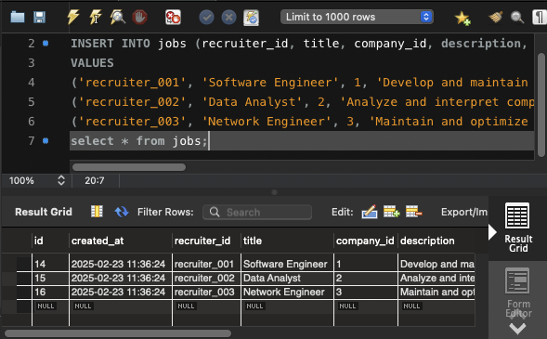

**4. Applications Table :**

CREATE TABLE applications (

id SERIAL PRIMARY KEY,

created_at TIMESTAMPTZ DEFAULT CURRENT_TIMESTAMP,

job_id INT NOT NULL,

candidate_id TEXT NOT NULL,

status TEXT CHECK (status IN ('pending', 'accepted', 'rejected')),

resume TEXT,

skills TEXT,

experience TEXT,

education TEXT,

name TEXT,

FOREIGN KEY (job_id) REFERENCES jobs(id) ON DELETE CASCADE

);

INSERT INTO applications (job_id, candidate_id, status, resume, skills, experience, education, name) VALUES

(1, 'candidate_001', 'pending', 'resume_link_1', 'Java, SQL', '3 years', 'B.Tech', 'Alice Johnson'),

(2, 'candidate_002', 'accepted', 'resume_link_2', 'Python, Data Analysis', '5 years', 'M.Sc Data Science', 'Bob Smith');

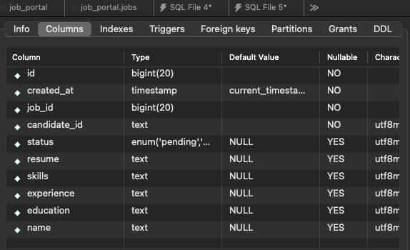

**5. Saved Jobs Table:**

CREATE TABLE saved_jobs (

id SERIAL PRIMARY KEY,

created_at TIMESTAMPTZ DEFAULT CURRENT_TIMESTAMP,

user_id TEXT NOT NULL,

job_id INT NOT NULL,

FOREIGN KEY (job_id) REFERENCES jobs(id) ON DELETE CASCADE

);

INSERT INTO saved_jobs (user_id, job_id) VALUES

('user_001', 1),

('user_002', 2);

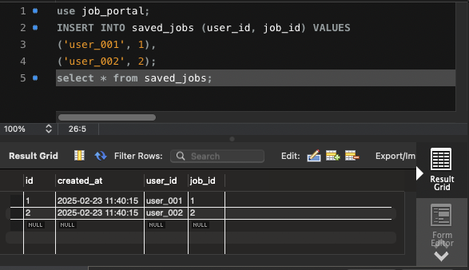

**6. Relationships:**

* Each job belongs to a company.
* Each application is linked to a job.
* Each saved job is linked to a user and a job.